Using the Communication Access Symbol

The Communication Access Symbol can be used anywhere, anytime and by anyone.
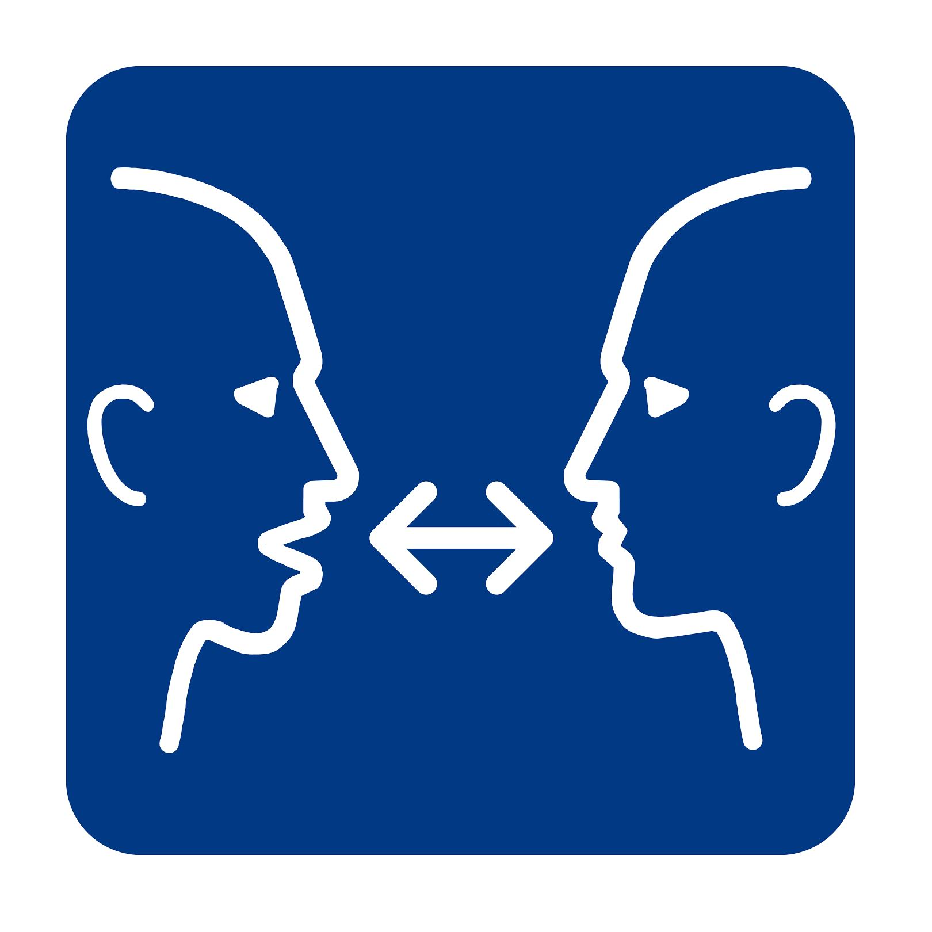
Show the symbol to raise awareness about:

- Communication access rights

- Different ways that people communicate

- What people can do when communicating with individuals who have communication disabilities

- How to make businesses and organizations communication accessible

Organizations can show the symbol to tell customers, clients and patients that they:

- Welcome people with communication disabilities

- Are willing and able to interact with people who have communication disabilities

- If applicable to the organization, they know how to:

  - communicate with people over the telephone and/or make alternate arrangements

  - make text, print and e-communications accessible

  - provide written forms in ways that people can understand, complete and sign

  - make meetings and public events communication accessible

- In critical communication situations, they have access to:

  - trained communication assistants

  - emergency picture, alphabet and other communication tools

More information: www.communication-access.org

