Communication Access Symbol
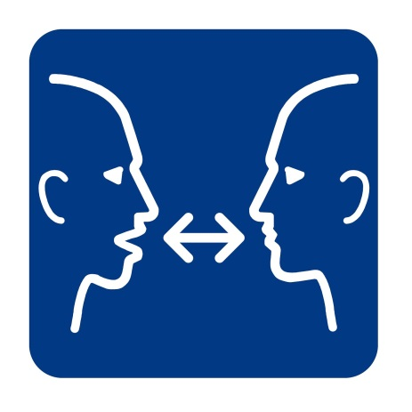
The communication access symbol tells people about effective communication.
Everyone benefits from effective communication, including people who have speech and language disabilities.
The communication access symbol shows that communication:
- Involves two people
- Is about interaction
- Is about giving as well as receiving information
- Is about listening and watching
Communication access means that people can:
- Understand what you are saying
- Have you understand their messages
- Use the communication methods that work best for them such as speech, gestures, writing, pointing to objects or pictures, spelling words, typing on a communication device or human assistance
- Read and understand your written information
- Sign your documents and complete forms in ways that are accessible for them
How we developed the symbol:
We developed the CDAC symbol by designing six potential options. We then asked members of the public across Canada to tell us what they thought each of the symbols meant. The public chose the symbol which contains two faces, one talking, both watching and a two-way arrow indicating an exchange or interaction.

